Title here, Calibri, bold, 16 points, centered

Author 1,ª Author 2,^{b}… (Calibri, 12 pt, centered, Presenting Author underlined)

ªAffiliation 1; ^{b}Affiliation 2…(Calibri, 10 points, italics, centered);
email: first.second@domain.edu

Body text (Calibri 12 points, justified; 1,0 line spacing).references, if any, in superscript with Arabic numbers

(up to one figure can be added to the abstract; centered with caption below)

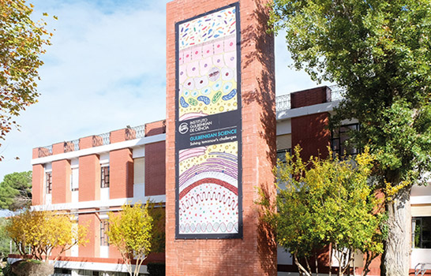

Figure 1. Caption (Calibri, 10 pt, centered)

References
- Calibri, 10 pt, sequentially numbered in Arabic, justified, ACS style is suggested, i.e: Author, A.; Author, B. Journal Acronym year, volume, initial page-final page.
- …

Acknowledgements
Calibri, 10 pt, justified

Please, keep within a single page

